
BAKERSFIELD COLLEGE

Electronics

Raspberry Pi Pico - Project 05: Breathing LEDs

1. Introduction
In previous studies, we know that LEDS have on/off state, so how to enter the intermediate state? How to output an intermediate state to make the LED "half bright"? That's what we're going to learn. Breathing lights, or LEDS turn on and off again, which are like "breathing". So, how to control the brightness of LEDS? We will use the Raspberry Pi Pico PWM to achieve this goal.

In this lesson, we will try something interesting – gradually increase and decrease the luminance of an LED with PWM, just like breathing. So we give it a magical name - Breathing LED.
In this guide, we will learn about the PWM, ie Pulse Width Modulation in Raspberry Pi Pico. We will be gradually changing the luminance of an LED through programming. Since the pulsing light looks like breathing, we give it a magical name – breathing LED. We’ll accomplish this effect with pulse width modulation (PWM).
Pulse Width Modulation or PWM is a common technique used to vary the width of the pulses in a pulse train. PWM has many applications such as controlling servos and speed controllers, limiting the effective power of motors and LEDs.

2. Components
Raspberry Pi Pico*1 | Raspberry Pi Pico Expansion Board*1 | Red LED*1 | 220Ω Resistor*1
Breadboard*1 | Jumper Wire*2 | USB Cable*1

Principle
PWM
Pulse Width Modulation, or PWM, is a technique for getting analog results with digital means. Digital control is used to create a square wave, a signal switched between on and off. This on-off pattern can simulate voltages in between full on (3.3 Volts) and off (0 Volts) by changing the portion of the time the signal spends on versus the time that the signal spends off. The duration of “on time” is called pulse width. To get varying analog values, you change, or modulate, that width. If you repeat this on-off pattern fast enough with some device, an LED for example, the result would be like this: the signal is a steady voltage between 0 and 3.3v controlling the brightness of the LED.
Duty Cycle
A duty cycle is the percentage of one period in which a signal is active. A period is the time it takes for a signal to complete an on-and-off cycle. As a formula, a duty cycle may be expressed as:
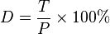
Where D is the duty cycle, T is the time the signal is active, and P is the total period of the signal. Thus, a 60% duty cycle means the signal is on 60% of the time but off 40% of the time. The “on time” for a 60% duty cycle could be a fraction of a second, a day, or even a week, depending on the length of the period.

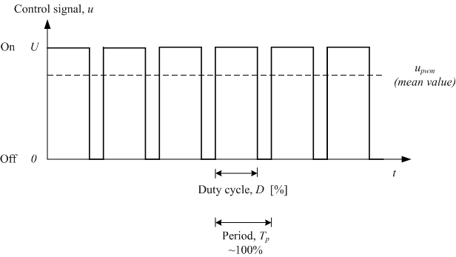

3. Knowledge

Analog & Digital
Analog signals are continuous signals in both time and value. In contrast, a digital or discrete time signal is a time series consisting of a series of numbers. Most signals in life are analog signals. A familiar example of an analog signal is how temperatures change continuously throughout the day, rather than suddenly changing from 0 to 10 in a flash. However, the value of a digital signal can change instantaneously. This change is represented numerically as 1 and 0(the basis of binary code). It's easier to see the difference, as shown below:
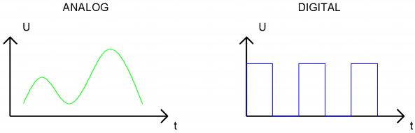
In practical applications, we often use a binary as a digital signal, which are a series of 0 and 1. Since binary signals have only two values(0 or 1), they have great stability and reliability. Finally, analog and digital signals can be converted to each other.
PWM：
Pulse Width Modulation (PWM) is an effective method to control analog circuit by digital signal. Ordinary processors cannot directly output analog signals. The PWM makes this conversion (convert digital signal to analog signal) very convenient, which uses digital pins to send square waves at a certain frequency, which is high and low output to alternate for a period of time. The total time of each set of high and low levels is generally fixed, which is called the period (Note: the reciprocal of the period is the frequency). The time of the high level output is usually called pulse width, and the duty cycle is the percentage of the pulse width (PW) to the total period (T) of the waveform. The longer the duration of the high level output as well as the duty cycle is, the higher the corresponding voltage in the analog signal will be. The figure below shows the variation of analog signal voltage from 0V to 3.3V(high level is 3.3V) corresponding to pulse width of 0% to 100%.
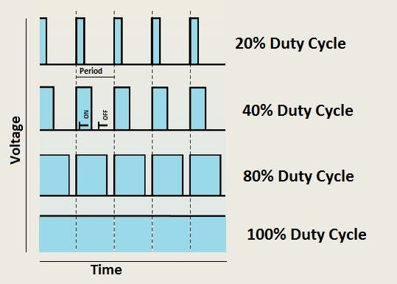
We all know that the longer the PWM duty cycle is, the higher the output power will be. Therefore, we can use PWM to control the brightness of LEDS or the speed of dc motors and so on. As can be seen from the above, the PWM is not a real analog signal, and the effective value of the voltage is equal to the corresponding analog signal. Therefore, we can control the output power of LEDS and other output modules to achieve different effects.
Raspberry Pi Pico and PWM
The Raspberry Pi Pico has 16 PWM channels, each of which can control frequency and duty cycle independently. The clock frequency ranges from 7Hz to 125MHz. Each pin on the Raspberry Pi Pico can be configured for PWM output.

4. Circuit Diagram and Wiring Diagram

In this experiment, we use this technology to make the LED brighten and dim slowly so it looks like our breath.
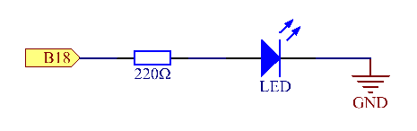

Experimental Procedures
Step 1: Build the circuit.

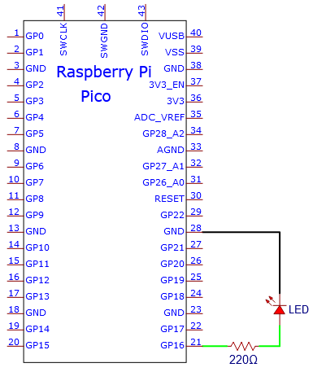
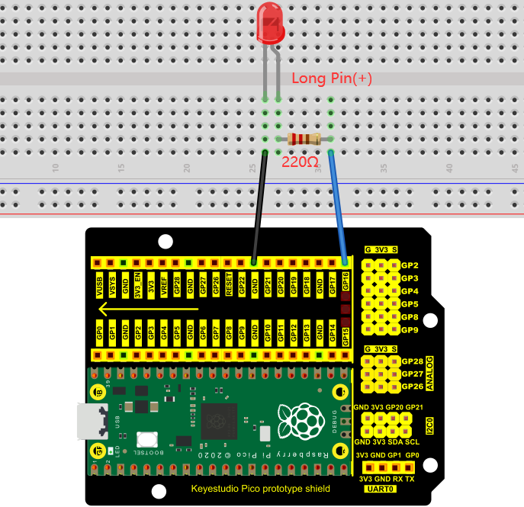
Note:
How to connect the LED
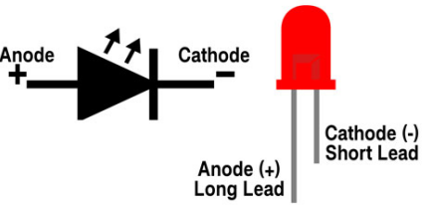
How to identify the 220Ω 5-band resistor
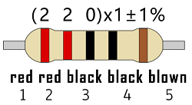

5. Test Code
The design of this project makes the GP16 output PWM, and the pulse width gradually increases from 0% to 100%, and then gradually decreases from 100% to 0%.
You can move the code to anywhere.For example, we save it in the pi folder of the Raspberry Pi system, the route is home/pi/Python_Codes.
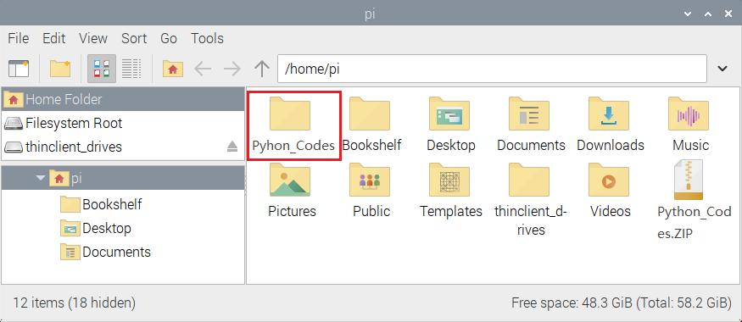
Open“Thonny, click“This computer”→“home”→“pi”→“Python_Codes”→”Project 04：Breathing Led”. And double-click “Project_04_Breathing_Led.py”.
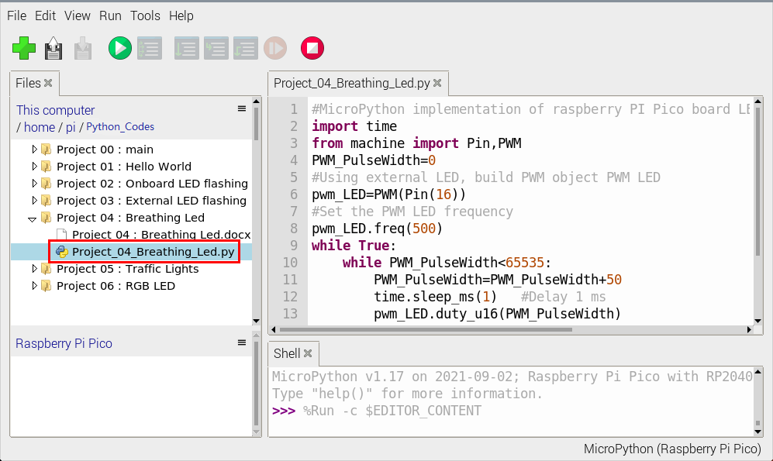
#MicroPython implementation of raspberry PI Pico board LED breathing lamp program example
import time
from machine import Pin,PWM
PWM_PulseWidth=0
#Using external LED, build PWM object PWM LED
pwm_LED=PWM(Pin(16))
#Set the PWM LED frequency
pwm_LED.freq(500)
while True:
while PWM_PulseWidth<65535:
PWM_PulseWidth=PWM_PulseWidth+50
time.sleep_ms(1) #Delay 1 ms
pwm_LED.duty_u16(PWM_PulseWidth)
while PWM_PulseWidth>0:
PWM_PulseWidth=PWM_PulseWidth-50
time.sleep_ms(1)
pwm_LED.duty_u16(PWM_PulseWidth)

6. Test Result：
Connect the pico board to the Raspberry Pi. Clickto check the Shell
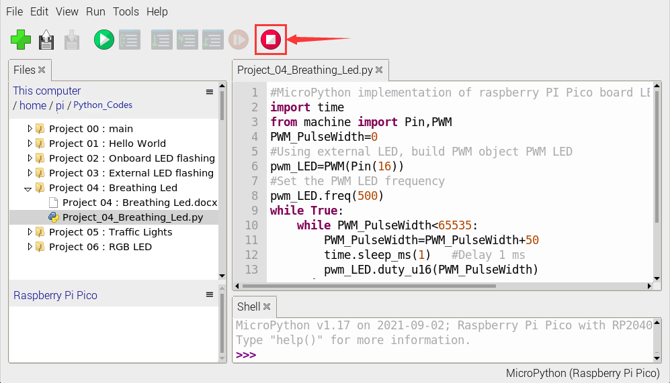
Click to run the code. Then the LED on the pico board will flash; click to exit the program.
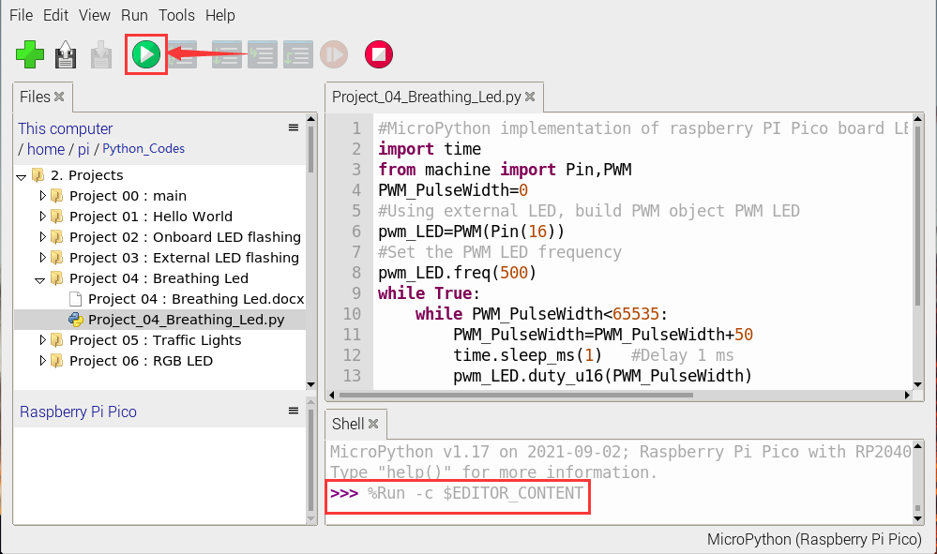
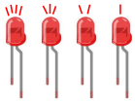

Pulse Width Modulation (PWM)
Pulse width modulation, or PWM, is a technique for getting analog results with digital means. Digital control is used to create a square wave, a signal switched between on and off. This on-off pattern can simulate voltages between full-on (5 Volts) and off (0 Volts) by changing the portion of the time the signal spends on versus the time that the signal spends off.
The duration of “on time” is called the pulse width. To get varying analog values, you change or modulate, that width. If you repeat this on-off pattern fast enough with some device, an LED, for example, it would be like this: the signal is a steady voltage between 0 and 5V controlling the brightness of the LED.
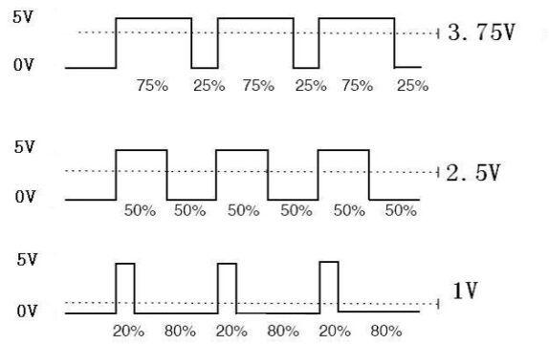
You will find that the smaller the PWM value is, the smaller the value will be after being converted into voltage. Then the LED becomes dimmer accordingly. Therefore, we can control the brightness of the LED by controlling the PWM value.

PWM Pins Raspberry Pi Pico
The RP2040 microcontroller at the core of the Raspberry Pi Pico has 8 Slices of PWM, and each Slice is independent of the others. This simply means that we can set the frequency of a Slice without affecting the others.
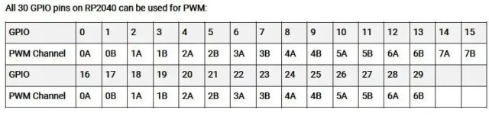
The RP2040 PWM block has 8 identical PWM slices, each with two output channels (A/B), where the B pin can also be used as an input for frequency and duty cycle measurement. That means each slice can drive two PWM output signals, or measure the frequency or duty cycle of an input signal. This gives a total of up to 16 controllable PWM outputs. All 30 GPIO pins can be driven by the PWM block.
An interesting thing at this moment to recall about PWM on the RP2040 is the possibility of having Duty Cycle values at 0% and at 100% without spurious peaks as happens on most other microcontrollers. Besides, it might be possible to have the two outputs of the same Slice with inverted phase signals.

WM Usage in Raspberry Pi Pico
In this example we will use a Raspberry Pi Pico PWM pin with an LED. Through PWM pulse width modulation, the LED light is controlled to light up gradually, and then gradually turn off, so as to form a breathing light effect in a cycle.
Connect the positive Pin of the LED to Pi Pico GP2 Pin and the negative Pin to GND.
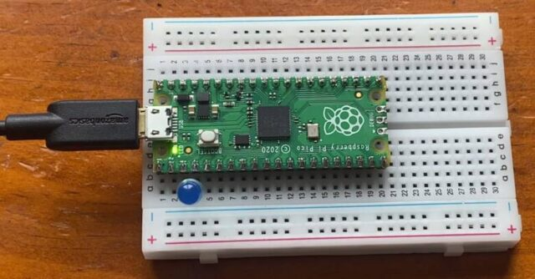

MicroPython Code/Program
1  2  3  4  5  6  7  8  9  10  11  12  13  14  15  16  17 | from machine import Pin, PWM  import utime  led = PWM(Pin(2))  led.freq(1000) # Set the frequency value  led_value = 0 #LED brightness initial value  led_speed = 5 # Change brightness in increments of 5  if __name__ == '__main__':  while True:  led_value += led_speed  led.duty_u16(int(led_value * 500)) # Set the duty cycle, between 0-65535  utime.sleep_ms(100)  if led_value >= 100:  led_value = 100  led_speed = -5  elif led_value <= 0:  led_value = 0  led_speed = 5
Copy the above code and run the script.
The LED connected to Raspberry Pi Pico will behave as a breathing LED as its illuminance and brightness change after regular inteval.

The LED connected to Raspberry Pi Pico will behave as a breathing LED as its illuminance and brightness change after regular inteval.
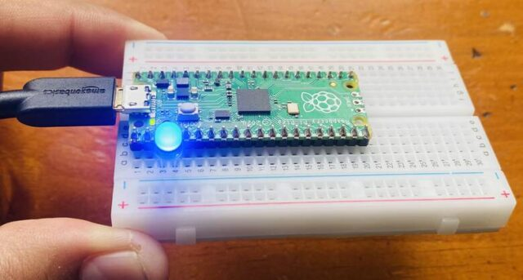
The frequency (led.freq) tells Raspberry Pi Pico how often to switch the power between on and off for the LED. The duty cycle tells the LED for how long it should be on each time. For Raspberry Pi Pico in MicroPython, this can range from 0 to 65025. 65025 would be 100% of the time, so the LED would stay bright. A value of around 32512 would indicate that it should be on for half the time.
This is how you can use (PWM) Pulse Width Modulation in Raspberry Pi Pico to control Breathing LED.

